Capstone Project Proposal
Predictive Modeling for Card Payment Fraud Detection in the Irish Banking Sector Using Central Bank of Ireland Data
1. Introduction
Card payment fraud has become one of the most significant operational and financial risks facing Irish banks. As digital payments continue to expand, fraudsters increasingly exploit online channels, social engineering, and cross-border vulnerabilities. According to the Central Bank of Ireland, fraudulent payment transactions reached €179.04 million in 2025, representing a 27.2% increase from 2024 (Central Bank of Ireland, 2025). Card payment fraud alone accounted for €51.01 million, an 18.6% rise compared to the previous year (Central Bank of Ireland, 2025). Notably, 89% of card payment fraud occurred through online channels, highlighting Irish consumers' growing exposure to digital fraud (Central Bank of Ireland, 2025).
This trend presents a strategic challenge for Irish banks. Fraud losses reduce profitability, damage customer trust, and increase regulatory pressure under frameworks such as PSD2 (Second Payment Services Directive) and Strong Customer Authentication (European Banking Authority, 2022). Traditional rule-based fraud detection systems are reactive and struggle to identify emerging fraud patterns (Bhattacharyya et al., 2011). As fraud becomes more sophisticated, predictive analytics offers a more effective approach to identifying suspicious behaviour and forecasting future fraud risks.
This project proposes a predictive modeling solution using the Central Bank of Ireland’s Card Payments Fraud datasets (2022–2025). The project will analyse fraud trends, identify behavioural patterns, develop classification and forecasting models, and produce a fraud risk scoring system to support strategic fraud prevention decision-making in the Irish banking sector.
2. Problem Definition
Fraudulent card transactions in Ireland have increased significantly over the past four years. Fraudsters increasingly target online and cross border channels, with cross border fraud representing 69.8% of total fraudulent value in 2025 (Central Bank of Ireland, 2025). These trends indicate that fraud is becoming more international, more digital, and harder for traditional systems to detect.
Irish banks face rising financial losses, reputational damage, and regulatory scrutiny. Current fraud detection systems rely heavily on static rules, which are insufficient for detecting new fraud patterns (Carcillo et al., 2021). The business problem is therefore:
Irish banks need a predictive analytics solution that identifies fraud patterns early, forecasts fraud trends, and supports strategic fraud prevention decisions.
This project addresses this problem by developing predictive models using official fraud statistics from the Central Bank of Ireland.
3. Aim and Objectives
Aim
To develop a predictive analytics solution that identifies, classifies, and forecasts card payment fraud in the Irish banking sector using Central Bank of Ireland fraud statistics from 2022–2025.

Objectives
- Analyse historical fraud trends across card-payment channels, fraud types, and transaction values (Central Bank of Ireland, 2025).
- Identify key behavioural and seasonal patterns associated with card-payment fraud.
- Develop predictive models to classify fraud types and forecast fraud volumes (Bhattacharyya et al., 2011).
- Evaluate model performance using appropriate metrics such as accuracy, F1-score, ROC-AUC, and RMSE.
- Produce a fraud-risk scoring framework to support strategic decision-making.
- Create a dashboard visualising fraud trends, predictions, and risk indicators.
4. Scope
Included
- Card Payments Fraud datasets (2022–2025)
- Exploratory Data Analysis (EDA)
- Feature engineering (fraud type, channel, seasonality, value bands)
- Predictive modelling (classification + forecasting)
- Dashboard development (Power BI / Tableau)
- Business strategy recommendations
- Ethical, legal, and GDPR considerations
- AI Fluency Framework declaration
- GitHub repository
Excluded
- Customer-level personal data
- Real-time fraud detection systems
- Integration with live banking systems
- Non-fraud card-payment datasets
- Confidential bank datasets
5. Methodology (CRISP-DM)
Business Understanding
Fraud losses are rising in Ireland, and banks need predictive tools to detect fraud early and reduce financial losses (Central Bank of Ireland, 2025). Predictive analytics can provide a competitive advantage by improving fraud detection accuracy (Carcillo et al., 2021).

Data Understanding
The project uses four datasets:
- Card Payments Fraud 2022
- Card Payments Fraud 2023
- Card Payments Fraud 2024
- Card Payments Fraud 2025
These datasets include fraud type, channel, transaction value, and reporting period.
Data Preparation
Data preparation includes:
- Merging all datasets
- Cleaning missing values
- Standardising column names
- Creating new features
Modeling
Models include:
- Logistic Regression
- Random Forest
- ARIMA / Prophet forecasting
Machine learning is widely used in fraud detection because it can learn complex patterns (Carcillo et al., 2021).
Evaluation
Metrics include:
- Accuracy
- Precision
- Recall
- F1-score
- ROC-AUC
- RMSE (forecasting)
Deployment
A dashboard will visualise fraud trends and predictions. A fraud-risk scoring system will support business decision-making.

High-Level Architecture Diagram
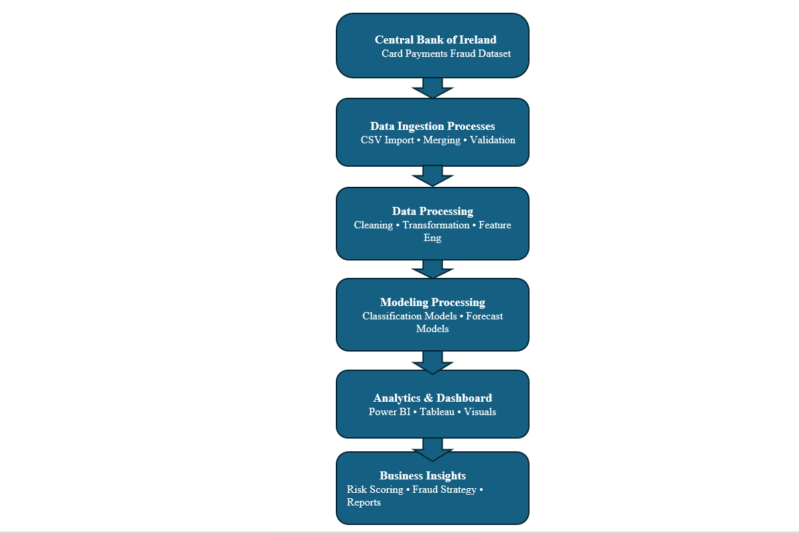
6. Data Source
The primary data source for this project is the Central Bank of Ireland’s Payment Fraud Statistics, published through its official Open Data Portal. These datasets contain semi‑annual and annual fraud‑related payment information reported by Irish Payment Service Providers (PSPs), including banks, credit unions, payment institutions, e‑money institutions, and payment service operators. The data is collected under the Payment Statistics Regulation introduced in 2022, which mandates reporting of both fraudulent and non‑fraudulent payment transactions across multiple payment methods (Central Bank of Ireland, 2025).
Card Payments Fraud Datasets (2022–2025)
This project specifically uses the Card Payments Fraud datasets for the years:
- Card Payments 2022 (Fraud)
- Card Payments 2023 (Fraud)
- Card Payments 2024 (Fraud)
- Card Payments 2025 (Fraud)
These datasets are available as downloadable CSV files via the Central Bank’s Open Data Portal and Data.gov.ie.
7. Expected Deliverables
- Combined fraud dataset (2022–2025)
- EDA report
- Predictive models
- Fraud-risk scoring system
- Dashboard
- Final report
- Presentation
- GitHub repository
- AI Fluency Declaration
8. Project Timeline (Gantt Chart)
- Semester 1
1–2 | Topic selection, proposal writing
3–5 | Data collection & merging
6–8 | EDA & feature engineering
9–11 | Initial modelling
12–13 | Interim report submission

